Project 9 – TIC TAC TOE:
By Yoav Damari and Jasmine Erell
Yoav.damari@post.runi.ac.il
Jasmine.erell@post.runi.ac.il

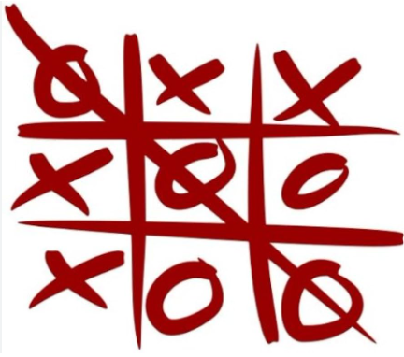

Concept:
Our Tic Tac Toe app is a two-player game implemented in JACK, where players alternate placing 'X' and 'O' symbols on a 3x3 grid. The goal is to align three of their symbols horizontally, vertically, or diagonally to win the game.
Architecture:
Main
Game
Start screen
Grid
X
Circle

• Main.jack
- Purpose: Entry point for the application.
- Logic: Initializes the Game class and starts the main game loop.
• Game.jack
- Purpose: Core logic and flow control of the game.
- Logic: Manages turns, tracks occupied cells, validates moves, and determines winning conditions.
• Grid.jack
- Purpose: Handles the layout of the 3x3 game board.
- Logic: Draws and manages the grid structure on the screen.
• StartScreen.jack
- Purpose: Displays the game's starting screen.
- Logic: Shows instructions and prompts the user to start the game.
• X.jack
- Purpose: Represents the 'X' player symbol.
- Logic: Draws the 'X' symbol on the specified grid cell.
• Circle.jack
- Purpose: Represents the 'O' player symbol.
- Logic: Draws the 'O' symbol on the specified grid cell.

Motivation:
We chose to create a Tic Tac Toe app because it’s a classic game that demonstrates essential programming concepts like logic control, grid management, and user interaction while being achievable within the constraints of the JACK programming language.

